
2010 JC2 H1 Prelim Paper Suggested Solution
 | 1 |  |  |  | The simplest hydride of boron is boron hydride of molecular formula B₂H₆. It has been suggested that gaseous boron hydride can be used as a rocket propellant, using either oxygen or fluorine as oxidants.  Combustion of boron hydride with oxygen yields a high melting point solid boron (III) oxide, B₂O₃ and water as the only products.
 |  |  | (a) |  | (i) |  | Write the balanced chemical equation for the reaction between boron hydride and oxygen. | [1]
 | B₂H₆ + 3O₂ → B₂O₃ + 3H₂O
 |  |  |  |  | (ii) |  | Using the information given below, calculate the standard enthalpy change for the above reaction. | [1]
  Substance | Standard enthalpy change of formation /  kJ mol⁻¹
  B₂O₃ | -1273
  B₂H₆ | +36
  H₂O | -286
Standard enthalpy change of reaction
= [-1273 + 3(-286)] – (+36)
= -2167 kJ mol⁻¹
 |  |  |  |  | (iii) |  | Using data from the Data Booklet and information below, identify the standard enthalpy terms ΔH^{ө}₁, ΔH^{ө}₂, ΔH^{ө}₃ and ΔH^{ө}₄ on the left hand side of the Born Haber Cycle.  Hence determine the lattice energy of boron (III) oxide. | [3]
  2B³⁺ (g) + 3O (g) | + 6e
  2x ΔH^{ө}₆
  2B²⁺ (g) + 3O (g) + 4e |  | 3 x EA of oxygen
  2 x ΔH^{ө}₅
  2B⁺ (g) + 3O (g) + 2e |  | 2B³⁺ (g) + 3O²⁻ (g)
  2 x ΔH^{ө}₄
  2B (g) + 3O (g)
  3 x ΔH^{ө}₃ |  | ΔH^{ө}_{latt}
  2B (g) + 3/2 O₂ (g)
  2 x ΔH^{ө}₂
  2B (s) + 3/2 O₂ (g)
  ΔH^{ө}₁
  B₂O₃ (s)
  Enthalpy term | ΔH^{θ} / kJ mol⁻¹
  Standard enthalpy change of formation of boron (III) oxide | -1273
  Standard enthalpy change of atomisation of boron | +573
  Standard enthalpy change of atomisation of oxygen | +248
  Sum of first and second electron affinity for oxygen | +702
ΔH^{ө}₁ is standard enthalpy change of formation of boron (III) oxide

ΔH^{ө}₂ is standard enthalpy change of atomisation of boron

ΔH^{ө}₃ is standard enthalpy change of atomisation of oxygen

ΔH^{ө}₄ is first ionisation energy of boron
2B³⁺ (g) + 3O (g)
3rd I.E
= 2(3660)

2B²⁺ (g) + 3O (g)
2nd I.E  = 2(2420) |  | 1st and 2nd E.A  = 3(702) =2106kJmol⁻¹
2B⁺ (g) + 3O (g) |  | 2B³⁺ (g) + 3O²⁻ (g)
1st I.E
= 2(799)
2B (g) + 3O (g)
ΔH_{a}(O)  = 3(248)=744 kJmol⁻¹ |  | ΔH_{lattice} of B₂O₃
2B (g) + 3/2 O₂ (g)
ΔH_{a}(B)
= 2(573)=1146 kJmol⁻¹
2B (s) + 3/2 O₂ (g)
ΔH_{f}= -1273 kJmol⁻¹
B₂O₃ (S)
ΔH_{lattice} (B₂O₃) = -1273–[1146+744 +2(799) +2(2420) +2(3660)+2106)]= -19027 kJ mol⁻¹
 |  |  | (b) |  |  |  | Paracetamol is a common analgesic and pyretic drug often used as a painkiller and for treating mild fever. In a study carried out to determine the rate of removal of paracetamol from the body, the reaction was found to have a constant half-life of 2.7 hours.  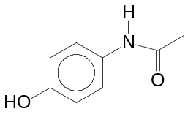  Paracetamol
 |  |  |  |  | (i) |  | Sketch a graph to show how 1 mol dm⁻³ of paracetamol decreases to 25% of its initial concentration. | [2]
Let the initial concentration of paracetamol be x.
candidate can start with 1 mol dm⁻³ or any appropriate concentration
[paracetamol]
Time / h
x
½ x
¼ x

2.7 5.4
 |  |  |  |  | (ii) |  | Write the rate equation for the reaction and calculate the value of the rate constant, k. | [2]
Rate = k [paracetamol]
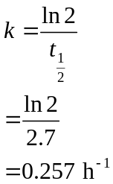

 |  |  |  |  | (iii) |  | Explain why Paracetamol is not very soluble in water. | [1]
The intermolecular forces of attraction between Paracetamol are primarily Van der Waals forces of attraction which is not able to displace the stronger hydrogen bonding in water. Hence it is not soluble in water.
Or presence of hydrophobic benzene ring.
 | Total: 10 marks
 | 2 |  |  |  |  |  | Alcohol B has the following structure:  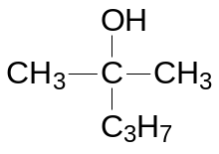
 |  |  | (a) |  |  |  | Draw the displayed formula of the possible isomers of alcohol B. Label your isomers for use in (b). | [2]
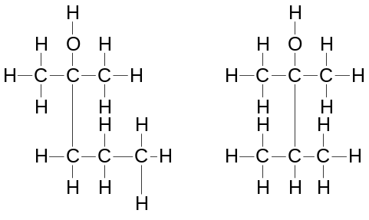

Alcohol 1 Alcohol 2

 |  |  | (b) |  |  |  | To the corresponding isomers of alcohol B in (a), concentrated sulfuric acid was added and products with molecular formula, C₆H₁₂ were obtained. Draw the structural formula of the products formed. | [2]
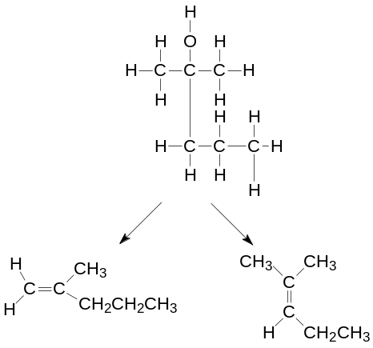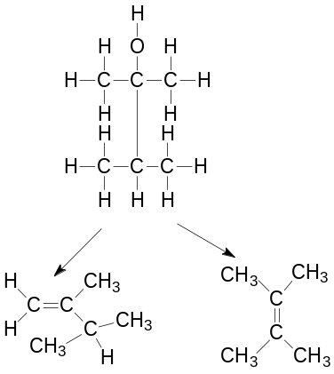
Products of alcohol 1 Products of alcohol 2

 |  |  | (c) |  |  |  | The boiling point of three organic compounds is given as follow:  Briefly explain the difference in their boiling point. | [2]
  Compound | Boiling Point
  Butene | 273 K
  Butan-1-ol | 390 K
  Butanoic acid | 437 K
Butene, butan-1-ol and butanoic acid are simple molecular substances.

Butene has weak intermolecular van der waals forces attraction while butan-1-ol and butanoic acid has stronger intermolecular hydrogen bonding.

Intermolecular hydrogen bonding in butanoic acid is more extensive than that of butan-1-ol.
Energy required:
Butanoic acid > Butan-1-ol > Butene

 |  |  | (d) |  |  |  | Organic compound C contains carbon, hydrogen and oxygen only.  10 cm³ of compound C undergoes complete combustion to produce 40 cm³ of carbon dioxide and 50 cm³ of water vapour. 1 mol of C produces 0.5 mol of hydrogen gas when sodium metal is added.  No effervescence was observed when compound C was reacted with sodium carbonate but white fumes of gas were seen when phosphorous pentachloride was added to compound C.  Upon reaction with acidified potassium manganate (VII), compound D was formed. Compound D reacts with 2,4-DNPH but did not react with Tollen’s reagent. Compound C and D both give yellow precipitate when reacted with alkaline aqueous iodine.  Compound C was passed through hot alumina and compound E was obtained as one of the products. When compound E undergoes strong oxidation, bubbles of gas were observed.  Draw the structures of Compound C, D and E. | [4]
From the combustion data:
10 cm³ of compound C gives 40 cm³ of CO₂ and 50 cm³ H₂O
Which means
1 mol of compound C gives 4 mol of CO₂ and 5 mol H₂O

CO₂ ≡ C ; H₂O ≡ 2H
Compound C contains 4 C and 10 H
Since 1 mol of C produces 0.5 mol of hydrogen gas when sodium metal is added ➔ presence of one alcohol group ➔ C₄H₁₀O
Yellow ppt
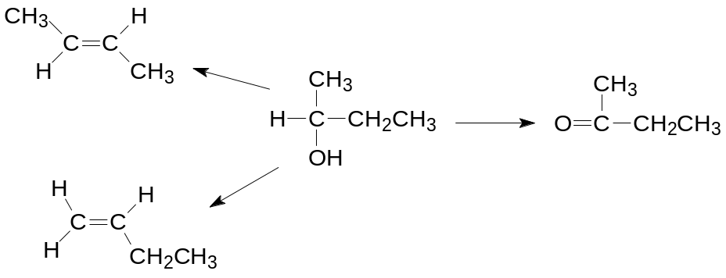
C
D
E
MnO₄⁻/H⁺
Hot alumina
Hot alumina
I₂/OH⁻
I₂/OH⁻
2,4-DNPH
Tollen’s
Reaction occurs
No Reaction
Strong oxidation

CO₂ gas produced due to terminal alkene

 | Total: 10 marks
 | 3 |  |  |  |  |  | Shikimic acid, is an important biochemical intermediate in plants and microorganisms.  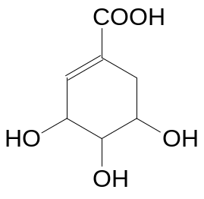  Shikimic acid
 |  |  | (a) |  |  |  | Draw the structural formulae of the organic products formed when shikimic acid is treated with HBr followed by hot aqueous NaOH. | [2]
 | 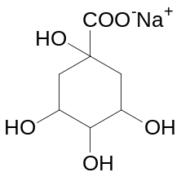
 |  |  | (b) |  |  |  | Apart from shikimic acids, cinnamic acid, zingerone and vanillin are other compounds that can be naturally isolated from plants and herbs.  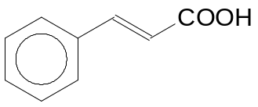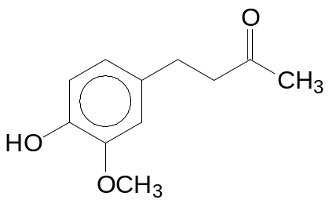  Cinnamic acid Zingerone  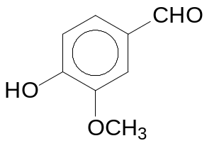 Vanillin  (for this question ignore the chemical effect of –OCH₃)
 |  |  |  |  | (i) |  | State one reagent and condition that will react with vanillin and not zingerone and describe what would be observed. | [2]
Reagent and condition: Tollen’s reagent, warm
Observation: Silver mirror

 |  |  |  |  | (ii) |  | State one reagent and condition, other than Br₂ and oxidising agent, that will react with cinnamic acid and not zingerone and describe what would be observed. | [2]
Reagent and condition: Na₂CO₃ (aq), rtp
Observation: effervescence produced (giving white ppt on passing gas produced through aqueous Ca(OH)₂ )
 |  |  | (c) |  |  |  | The carbonyl functional group undergoes a series of reactions which follow the following pattern:  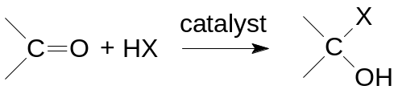  Where X can be CN, OCH₃, etc.  Using the above information, draw the structural formula of the product formed for the following reactions:
 |  |  |  |  | (i) |  | Addition of HCN to 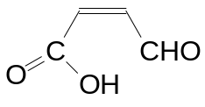, followed by a dehydration process. | [1]
 |  |  |  |  |  |  | 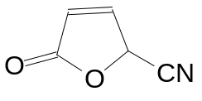
 |  |  |  |  | (ii) |  | Addition of CH₃OH to vanillin, followed by an oxidation reaction.  (Note: –OCH₃ is inert to oxidation) | [1]
 |  |  |  |  |  |  | 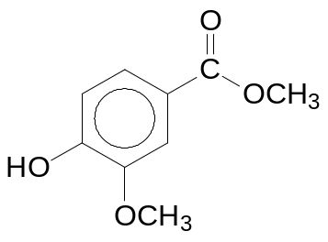
 |  |  | (d) |  |  |  | Shikimic acid undergoes complete combustion to form carbon dioxide and water. Construct a reaction pathway diagram for the combustion process. In your diagram, clearly indicate the enthalpy change of combustion and activation energy. | [2]
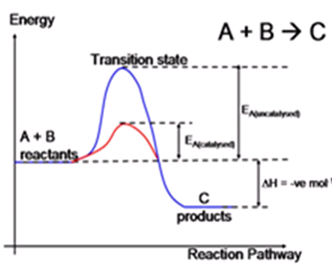
Transition State

Shikimic acid
Activation Energy
Enthalpy change of combustion
CO₂ and H₂O
Reaction Pathway

 | Total: 10 marks
 | 4 |  | (a) |  | (i) |  | On the grid below, sketch the trend of the ionic radii of elements in Period 3 from sodium to chlorine.  [1]
 |  |  |  |  | (ii) |  | Explain the trend of the ionic radii for elements in Period 3. [3]
ionic
radii / nm
 |  |  |  | optional |  | Element
Na Mg Al Si P S Cl
[1m]. Correct sloping and relative position.
Na, Mg and Al (and Si) form cations while P, S and Cl form anions. Anionic radii are larger than cationic radii because they have 1 more quantum shell of electrons.

Generally, ionic radius decreases across the period. Nuclear charge increase across the period, while the ions are isoelectronic to one another. Thus, valence electrons experience stronger electrostatic forces of attraction from the nucleus across the period, pulling them closer towards the nucleus / reducing the distance between valence electrons and nucleus.
 |  |  | (b) |  |  |  | The first six ionisation energies of three successive elements in a Periodic Table are given below:
   | Ionisation Energy in kJ mol⁻¹
  Element | 1st | 2nd | 3rd | 4th | 5th | 6th
  F | 786 | 1580 | 3230 | 4360 | 16100 | 19800
  G | 1060 | 1900 | 2920 | 4960 | 6270 | 21300
  J | 1000 | 2260 | 3390 | 4540 | 7000 | 8500
 |  |  |  |  | (i) |  | State and explain the Group which element G belongs to. | [2]
Group V
Drastic increase in ionization energy occur from 5th IE to 6th IE indicating the 6th electron removed is found in the inner quantum shell, hence, there are 5 electrons in the valence shell of G
 |  |  |  |  | (ii) |  | Explain why the first ionisation energy of G is  higher than F:  and higher than J: | [2]
F: ns²np²
G: ns²np³
J: ns²np⁴
1st IE of G is higher than F because nuclear charge of G is higher than F and the valence electrons of F and G are found in the same subshell, thus the valence electron on G experiences stronger electrostatic forces of attraction from the nucleus.
1st IE of G is higher than J because of inter-electron repulsion between the paired electrons occupying the same p-orbital in J. Lesser energy is required to remove it.
 |  |  |  |  | (iii) |  | Suggest a chemical formula of an oxide of element J and predict the type of bonding present in the oxide of J. | [2]
Formula of oxide of J: JO₂ or JO₃
Type of bonding present in oxide of J: Covalent bonding
 |  |  |  |  | (iv) |  | With aid of an equation, predict a pH value for the resulting solution obtained when the oxide of J is dissolved in water. | [2]
JO₂ + H₂O → H₂JO₃ or JO₃ + H₂O → H₂JO₄
pH = 1, 2 or 3 (any one)
 | Total: 10 marks
 |  |  |  | Paper 2 Section B
5 |  | (a) |  | 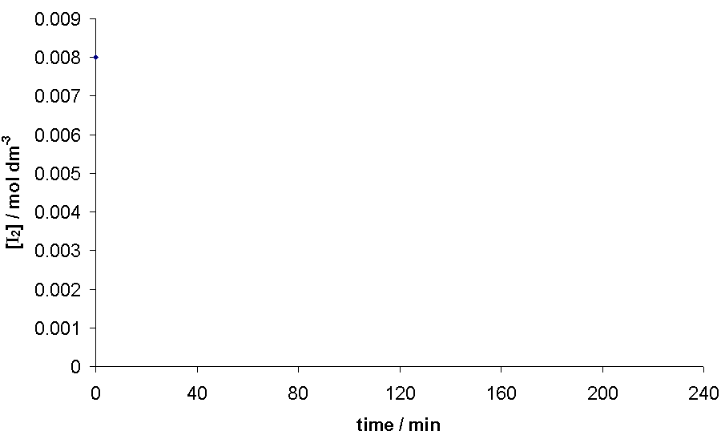  The kinetics of the acid–catalysed reaction of propanone with iodine can be investigated experimentally by varying the concentrations of the three substances involved.  [I₂] / mol dm^{–3}  [H⁺] = 0.20 mol dm^{–3}  [CH₃COCH₃] = 0.10 mol dm^{–3}  [H⁺] = 0.10 mol dm^{–3}  time / min  time / min  [H⁺] = 0.10 mol dm^{–3}  [CH₃COCH₃] = 0.10 mol dm^{–3}  [I₂] / mol dm^{–3}  [CH₃COCH₃] = 0.15 mol dm^{–3}  time / min  CH₃COCH₃(aq) + I₂(aq) CH₂ICOCH₃(aq) + HI(aq)  The following results were obtained in an experiment.
 |  |  |  | (i) |  | Deduce, with reasoning, the order of reaction with respect to (1) I₂, (2) H⁺ and (3) CH₃COCH₃. |  |  | [5]
Since [I₂] vs time graph is a straight line, rate of reaction is independent of [I₂].
Order of reaction is zero wrt I₂.

Using the 1st graph,

Rate when [H⁺] = 0.20 mol dm^{–3} :
-(0.008-0.002) / (0-120) = 5 x 10⁻⁵ moldm⁻³min⁻¹

Rate when [H⁺] = 0.10 mol dm^{–3} :
-(0.008-0.002) / (0-240) = 2.5 x 10⁻⁵ moldm⁻³min⁻¹
When [H⁺] doubles, the rate also doubles.
Order of reaction is one wrt H⁺.

Using the 2nd graph,

Rate ([CH₃COCH₃] = 0.10 mol dm^{–3}):
-(0.008-0.002) / (0-240) = 2.5x10⁻⁵ moldm⁻³min⁻¹

Rate ([CH₃COCH₃] = 0.15 mol dm^{–3}):
-(0.008-0.002)/(0-160) = 3.75x10⁻⁵ moldm⁻³min⁻¹

When [CH₃COCH₃] increases by 1.5X, the rate also increases by 1.5X.
Order of reaction is one wrt CH₃COCH₃.

 |  |  |  | (ii) |  | Hence, write a rate equation for the reaction and determine a value for the rate constant k, including its units. |  |  | [3]
Rate = k[CH₃COCH₃][H⁺]

Using graph 1,
5x10⁻⁵ = k (0.1)(0.2)
k = 2.50 x 10⁻³ mol⁻¹dm³ min⁻¹
 |  |  |  | (iii) |  | Predict, with reasoning, the effect of a catalyst on the activation energy and rate constant of a reaction. |  |  | [2]
A catalyst lowers the activation energy by providing an alternative pathway for reaction to take place.

The forward reaction is favoured which results in a larger rate constant.

 |  | (b) |  | Propanoic acid and citric acid are some of the acids used in the formulation of hair shampoo. A chemistry student wanted to formulate a shampoo with maximum buffer capacity so that there will be minimal damage to the hair.  In an attempt to prepare a buffer for the shampoo, she titrated 20.0 cm³ of 0.100 mol dm⁻³ sodium hydroxide against 0.20 mol dm⁻³ citric acid.
 |  |  |  | (i) |  | Deduce, with reasoning, whether propanoic acid or 2-chloropropanoic acid is a stronger acid. |  |  | [2]
Electron withdrawing Cl disperses the negative charge on oxygen.
This stabilises the conjugate base and 2-chloropropanoic acid is a stronger acid compared to propanoic acid.

 |  |  |  | (ii) |  | Calculate the pH of 0.100 mol dm⁻³ sodium hydroxide. |  |  | [1]
pOH= -log [OH⁻] = - log (0.1) = 1
pH = 14-1 = 13
 |  |  |  | (iii) |  | Calculate the volume of citric acid required to completely neutralise 20.0 cm³ of sodium hydroxide. |  |  | [2]
Amt of NaOH = 20/1000 x 0.1 = 0.002 mol
Citric acid ≡ NaOH
Vol of citric acid = 0.002 / 0.2 = 10.0 cm³

 |  |  |  | (iv) |  | When excess citric acid is added, a buffer solution is obtained.  Explain, with the aid of equations, how the mixture can act as a buffer upon addition of a small amount of acid and alkali.  (Citric acid could be represented by C₅H₇O₄COOH) |  |  | [2]
When H⁺ is added,
H⁺ + C₅H₇O₄COO⁻ → C₅H₇O₄COOH

When OH⁻ is added,
C₅H₇O₄COOH + OH⁻ → C₅H₇O₄COO⁻ + H₂O

 |  |  |  | (v) |  | The pH of 1 mol dm⁻³ of propanoic acid is 4 while the pH of 1 mol dm⁻³ of hydrochloric acid is 1. Explain the difference in their pH. |  |  | [1]
Propanoic acid is a weak acid and dissociates partially to produce low [H⁺] while hydrochloric acid dissociates completely to produce high [H⁺].

Since pH=-log [H⁺]

Hence pH of propanoic acid is 4 while pH of hydrochloric acid is 1.

 |  |  |  | (vi) |  | Suggest with reasoning, if the same volume of hydrogen gas will be produced if propanoic acid and hydrochloric acid, of the same concentration and volume are to react with 2.0 g of zinc metal under the same condition. |  |  | [2]
- CH₃COOH ⇌ CH₃COO⁻ + H⁺
- HCl → H⁺ + Cl⁻
- 2H⁺ + Zn → Zn²⁺ + H₂

Same volume of H₂ gas will be produced in both cases.
Reason:
Since H⁺ reacts with zinc, for (1), [H⁺] will decrease and by LCP, equilibrium position of (1) will shift right, hence all CH₃COOH will be reacted eventually producing the same amount of H₂ gas.

6 | (a) | Compound K has a composition of 46.15% C, 7.69% H and 46.15% O. It is formed when compound L (a bromo-containing organic substance) is refluxed with aqueous sodium hydroxide followed by acidification.  Effervescence was observed when sodium carbonate was added to K. Upon treatment of K with acidified potassium dichromate (VI), compound M is produced. Compound M reacts with 2,4-dinitrophenylhydrazine to form an orange hydrazone, N. On reaction of M with Fehling’s reagent, the reddish brown deposit was however not observed.  A yellow precipitate was observed when K and M were warmed with alkaline aqueous iodine. When K is refluxed with concentrated sulfuric acid, a sweet smelling compound P, C₈H₁₂O₄ is formed.  Deduce the structures of K, L, M, N and P. Maximum credit cannot be awarded just by drawing of the structures only. |  | [10]
 | C | H | O
% by mass | 46.15 | 7.69 | 46.15
A_{r} | 12 | 1 | 16
Amount | 3.85 | 2.67 | 2.88
Simplest ratio | 4 | 8 | 3

The empirical formula of K is C₄H₈O₃.

L undergoes nucleophilic substitution and neutralisation with aqueous sodium hydroxide, followed by acidification to form K.
⇒ L contains halogenoalkane.

K undergoes neutralisation with sodium carbonate to produce effervescence.
⇒ K contains carboxylic acid group.

K and M undergoes oxidation with alkaline solution with iodine.
⇒ They contain the structure 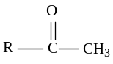 or 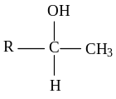

K undergoes oxidation with K₂Cr₂O₇ to form M
⇒ K is a secondary alcohol

M undergoes condensation with 2,4 DNPH but do not undergo oxidation with Fehling’s reagent.
⇒ M contains a ketone

A undergoes self esterification when refluxed with concentrated sulphuric acid to form E.
⇒ P is an ester
⇒ K contains an alcohol and an acid group.

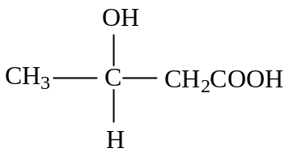K
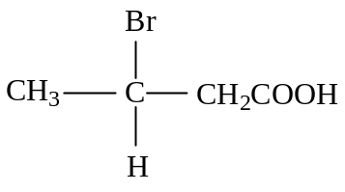L
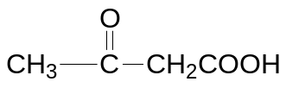 M

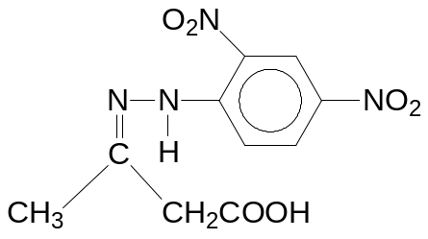N

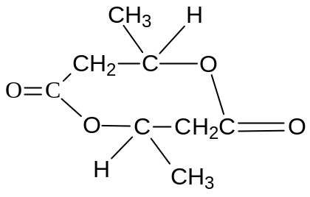P

Max 5 for reasonings and Max 5 for structures

 | (b) |  | Suggest a simple chemical test to distinguish between the following compounds:  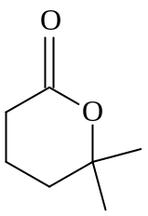and 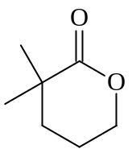 | [3]
Test: Add acidified potassium manganate to separate test tubes of each compound and reflux.
Observations:
: No decolourisation of purple KMnO₄.
: Decolourisation of purple KMnO₄.

 | (c) |  | Antimony pentachloride (SbCl₅) decomposes in a gas phase reaction at high temperature.  SbCl₅ (g) ⇌ SbCl₃ (g) + Cl₂ (g) ΔH = negative  At some temperature, dynamic equilibrium is established. An equilibrium mixture in a 5 dm⁻³ container is found to contain 6.91 g of SbCl₅, 16.45 g of SbCl₃ and 5.11 g of Cl₂.
 |  | (i) | What is meant by the term dynamic equilibrium? | [1]
 |  |  | A dynamic equilibrium is one where rate of forward reaction equals rate of backward reaction in a reversible reaction.
 |  | (ii) | Determine the K_{c} expression and hence calculate K_{c} for the above equilibrium. | [3]
K_{c} = 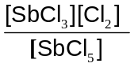
[SbCl₅] = 4.614 x 10⁻³ mol dm⁻³
[SbCl₃] = 0.014398 mol dm⁻³
[Cl₂] = 0.014394 mol dm⁻³

K_{c} = 0.0449 mol dm⁻³
 |  | (iii) | Using Le Chatelier’s Principle, state and explain the effect on the position of equilibrium and the equilibrium composition when:  - temperature is decreased at constant pressure,  - pressure is decreased at constant temperature. | [3]
According to Le Chatelier’s Principle, the position of equilibrium shifts to the right to release heat, favouring the exothermic reaction.

[SbCl₃] and [Cl₂] will increase while [SbCl₅] decrease until a new equilibrium is reached.

According to Le Chatelier’s Principle, the position of equilibrium shifts to the right to increase no of gaseous molecules.

[SbCl₃] and [Cl₂] will increase while [SbCl₅] decrease until a new equilibrium is reached.

7 | (a) | The oxides of sodium to phosphorus (Na₂O, MgO, Al₂O₃, SiO₂ and P₄O₁₀) differ in their bonding and reactions with water.
 |  | (i) | Complete the following graph on your answer script.  You are to indicate clearly on your graph the pH of the resulting solution when each oxide reacts with water.  pH  13  9  7  Na₂O MgO Al₂O₃ SiO₂ P₄O₁₀  2 | [2]
 |  | (ii) | With the aid of equations, state the pH of the solution obtained when aluminium chloride is dissolved in water. | [2]
AlCl₃ + 6H₂O →[Al (H₂O)₆]³⁺ + 3Cl⁻
[Al(H₂O)₆]³⁺ → [Al(H₂O)₅(OH)]²⁺ + H⁺
pH = 3
 |  | (iii) | A student was instructed to perform tests to deduce the identities of two chemical bottles with missing labels. The bottles contain either gallium oxide or selenium oxide.  The student first labelled the two bottles as Q and R. Then, he conducted solubility tests and record his observations as follows:  Sample Q dissolves in both hydrochloric acid and aqueous sodium hydroxide while sample R dissolves in aqueous sodium hydroxide only.  Suggest the identities of Q and R and write equations to show the acid-base behaviour of the oxides.  [Gallium is ₃₁Ga; Selenium is ₃₄Se] | [4]
Q: Ga₂O₃ / gallium oxide R: SeO₂ / selenium oxide

- Ga₂O₃ (s) + 6HCl (aq) → 2GaCl ₃ (aq) + 3H₂O (l)
- Ga₂O₃ (s) + 2NaOH (aq) + 3H₂O (l) → 2NaGa(OH)₄ (aq)
- SeO₂ (s) + 2NaOH (aq) →Na₂SeO₃ (aq) + H₂O (l)

(b) |  | Ethanol is a chemical which is widely used as a solvent, fuel and an important intermediate in large scale synthesis of organic compounds.  When 2.00 g of ethanol was burned under a container of water, the heat released was found to increase the temperature of 150 g of water from 28ºC to 65ºC.
 |  | (i) | Write a balanced equation, with state symbols, to represent the standard enthalpy change of combustion of ethanol. | [1]
 |  |  | CH₃CH₂OH (l) + 3O₂ (g) → 2CO₂ (g) + 3H₂O (l)
 |  | (ii) | Using the data given above, calculate the enthalpy change of combustion of ethanol. | [2]
Heat absorbed by water, Q = mcT = (150)(4.18)(65–28)
= 2.3199 x 10⁴ J = 23.20 kJ
Amount of ethanol burnt = 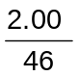= 0.04348 mol
Enthalpy change of combustion = – 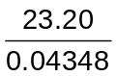= – 534 kJ mol⁻¹ .
 |  | (iii) | Using bond energy values from the Data Booklet, calculate another value for the standard enthalpy change of combustion of ethanol. Suggest an explanation for the discrepancy between your answer and the calculated value in b(ii). | [3]
= [(1x350) + (5x410) + (1x460) + (360x1) + (3 x 496) – [(740x4) + (460x6)] = 4708 – 5720 = -1012 kJ mol⁻¹

Bond energies used in this calculation are average values.
Or Answer did not consider the condensation of water.
 | (c) | Glycolic acid is the smallest α-Hydroxy acids (AHAs). It is also one of the main ingredients used in the manufacture of skin care products due to its excellent capability to penetrate human skin.  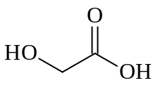  Glycolic Acid
 |  | (i) | Show how glycolic acid can be synthesized from methanol via three steps. In your answer, show clearly the reagents, conditions and intermediates involved. | [3]
Step 1
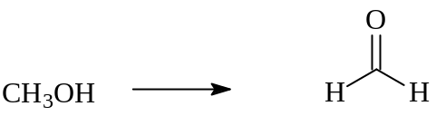
Reagents: acidified K₂Cr₂O₇
Conditions: Distlillation

Step 2
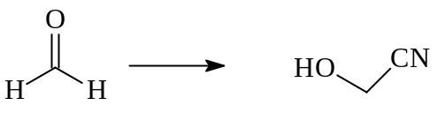
Reagents: HCN with trace amount of NaOH / NaCN
Conditions: cold 10 – 20ºC

Step 3

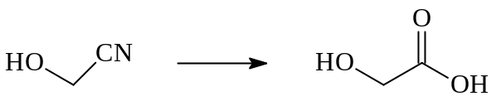
Reagents: aq HCl / aq H₂SO₄
Conditions: Heat/ reflux

Alternative:
Step 1: Limited amount of Cl₂ or excess methanol
(free radical substitution)
Step 2: alcoholic NaCN, heat (nucleophilic substitution)
Step 3: dilute HCl, heat (acidic hydrolysis)

 |  | (ii) | State the product(s) formed when hot acidified potassium manganate (VII) is added to glycolic acid. | [1]
 |  |  | CO₂ and H₂O
 |  | (iii) | Explain, with the aid of a diagram, why the relative molecular mass of glycolic acid is 152 when dissolved in a suitable solvent. | [2]
Dimerisation occurred. .
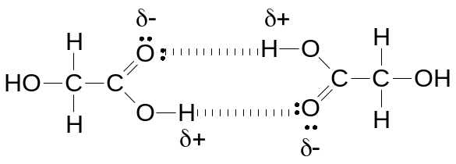

END OF CORRECTION TEMPLATE

